**NEPAL COLLEGE OF INFORMATION TECHNOLOGY**

Balkumari, Lalitpur

*Affiliated to Pokhara University*

**LAB REPORT FOR DATABASE MANAGEMENT SYSTEM**



**LAB REPORT 3: FAMILIARIZATION WITH VARIOUS CONSTRAINTS IN SQL**

Submitted by: Submitted to:

Name: Arpan Adhikari Er. Simanta Kasaju

Roll No.: 231309

BE-CE (3rd SEM)

|  |  |  |  |
| --- | --- | --- | --- |
| **S. N** | **LAB TOPIC** | **DATE** | **REMARKS** |
| **1.** | **INTRODUCTION TO SQL** | 10th Nov |  |
| **2.** | **FAMILIARIZATION WITH DDL COMMAND** | 17th Nov |  |
| **3.** | **FAMILIARIZATION WITH VARIOUS CONSTRAINTS IN SQL** | 24th Nov |  |
|  |  |  |  |
|  |  |  |  |
|  |  |  |  |
|  |  |  |  |
|  |  |  |  |
|  |  |  |  |

**LAB 3: FAMLIARIZATION WITH VARIOUS CONSTRAINTS IN SQL**

**OBJECTIVE:**

The objective of this practical is to understand and implement various constraints in SQL to ensure data integrity and consistency in a database. By exploring constraints such as NOT NULL, UNIQUE, PRIMARY KEY, FOREIGN KEY, CHECK, DEFAULT, and AUTO_INCREMENT, students will learn how to apply rules to restrict data and maintain valid relationships between tables.

**THEORY:**

SQL constraints are rules enforced on database tables to ensure data integrity, consistency, and validity. They define the type of data allowed in a table and restrict certain operations that might compromise the data quality. Below is an overview of the main constraints used in SQL:

### Types of Constraints in SQL

1. NOT NULL Constraint  
   Ensures that a column cannot have a NULL value.  
   Used to mandate that specific fields contain data.
2. UNIQUE Constraint  
   Ensures that all values in a column are distinct.  
   Multiple columns can be combined to create a composite UNIQUE constraint.
3. PRIMARY KEY Constraint  
   Combines NOT NULL and UNIQUE constraints to uniquely identify each record in a table.  
   A table can have only one primary key.
4. FOREIGN KEY Constraint  
   Ensures referential integrity by linking a column in one table to a PRIMARY KEY column in another table.
5. CHECK Constraint  
   Ensures that values in a column satisfy a specific condition.
6. DEFAULT Constraint  
   Assigns a default value to a column if no value is specified during insertion.
7. INDEX  
   Improves query performance by creating a pointer to data in a table.  
   Unlike other constraints, an index is not about restricting data but speeding up retrieval.
8. AUTO_INCREMENT  
   Used to generate a unique identifier for a column (commonly used for primary keys).

### Practical Implementation

#### Step 1: Creating a Table with Constraints

Constraints like NOT NULL, PRIMARY KEY, CHECK, and FOREIGN KEY are added directly when defining the table structure.

#### Step 2: Adding Constraints to an Existing Table

Constraints can be added to a table after it has been created using the ALTER TABLE command.

#### Step 3: Dropping Constraints

Constraints can be removed using the ALTER TABLE command and specifying the constraint name.

#### Step 4: Viewing Table Structure

The structure of a table, including constraints, can be viewed using commands like DESCRIBE or SHOW CREATE TABLE.

**Questions:**

**Question:**

1. **Creating a table:**

**Syntax:**

create table student

(ID int primary key,

NAME varchar(20),

AGE int not null CHECK(AGE > 20) ,

ADDRESS varchar(20) DEFAULT 'KATHMANDU',

MOBILE BIGINT UNIQUE);

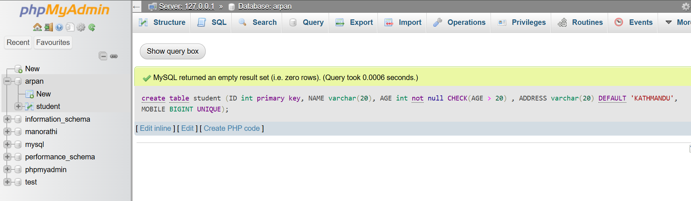

1. **Creation of other tables from existing table**:

**SYNTAX:**

CREATE TABLE stud (

sid INT PRIMARY KEY,

id INT,

fee_pay INT,

fee_due INT,

FOREIGN KEY (id) REFERENCES student(id)

);

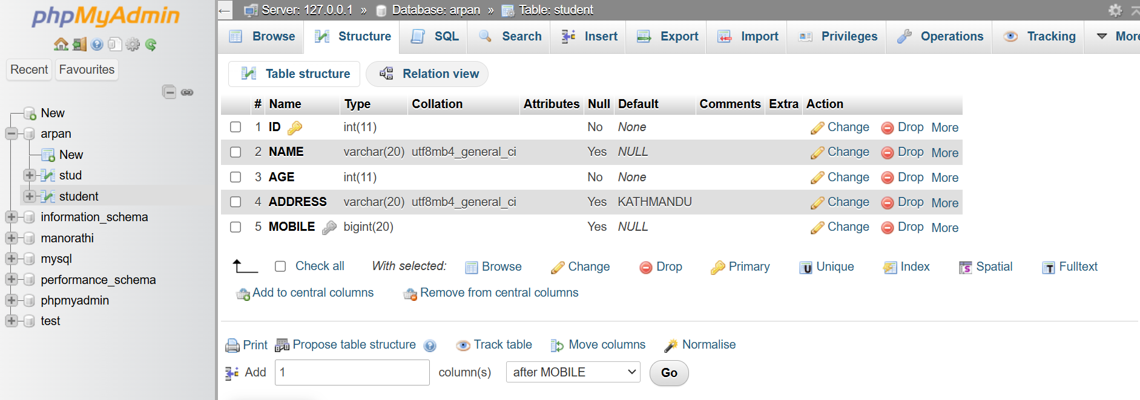

1. **Adding new column to student table:**

**SYNTAX:**

ALTER TABLE student

ADD gender VARCHAR(10) DEFAULT 'male';

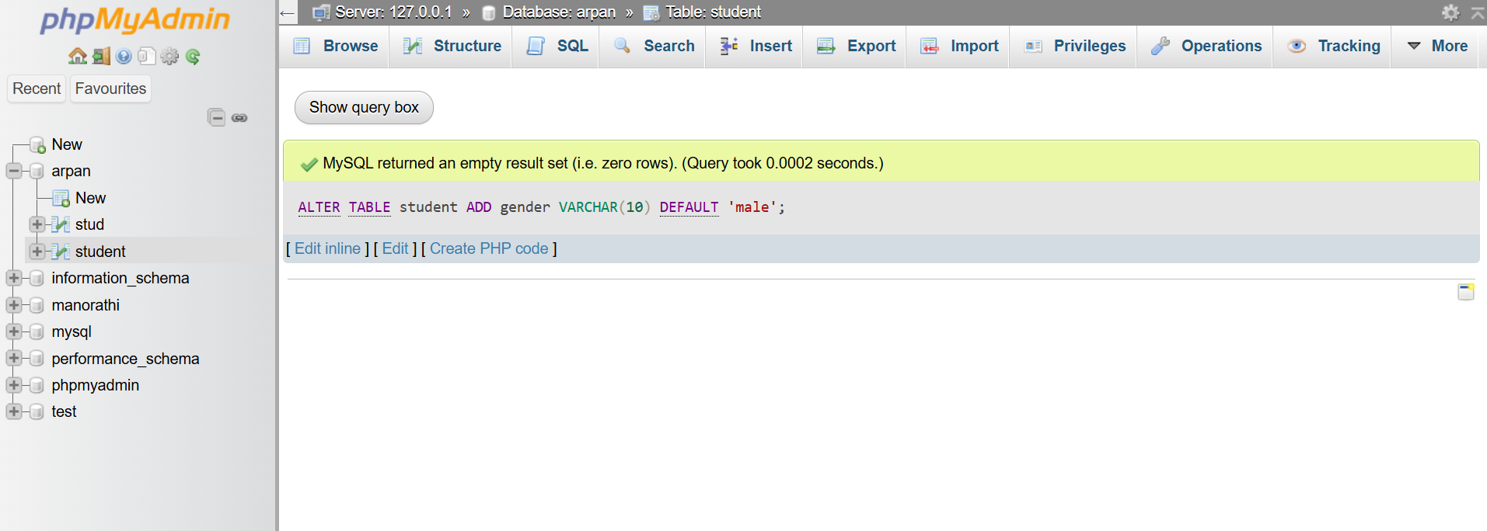

1. **Inserting 5 records (Invalid insertion):**

INSERT INTO student (id, name, age, mobile, address, gender) VALUES

(1, 'Alice', 19, '1234567890', 'ktm', 'female'),

(2, 'Bob', 18, '0987654321', 'ktm', 'male'),

(3, 'Charlie', 17, '1111111111', 'pokhara', 'male'),

(4, 'Daisy', 15, '2222222222', 'biratnagar', 'female'),

(5, 'Invalid', 21, '4444444444', 'ktm', 'male');

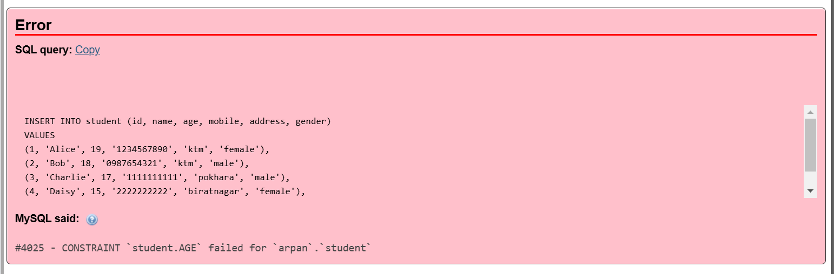

1. **Inserting 5 records and Displaying (valid insertion):**

**SYNTAX:**

INSERT INTO student (id, name, age, mobile, address, gender) VALUES

(1, 'Alice', 21, '1234567890', 'ktm', 'female'),

(2, 'Bob', 22, '0987654321', 'ktm', 'male'),

(3, 'Charlie', 22, '1111111111', 'pokhara', 'male'),

(4, 'Daisy', 23, '2222222222', 'biratnagar', 'female'),

(5, 'valid', 21, '4444444444', 'ktm', 'male');

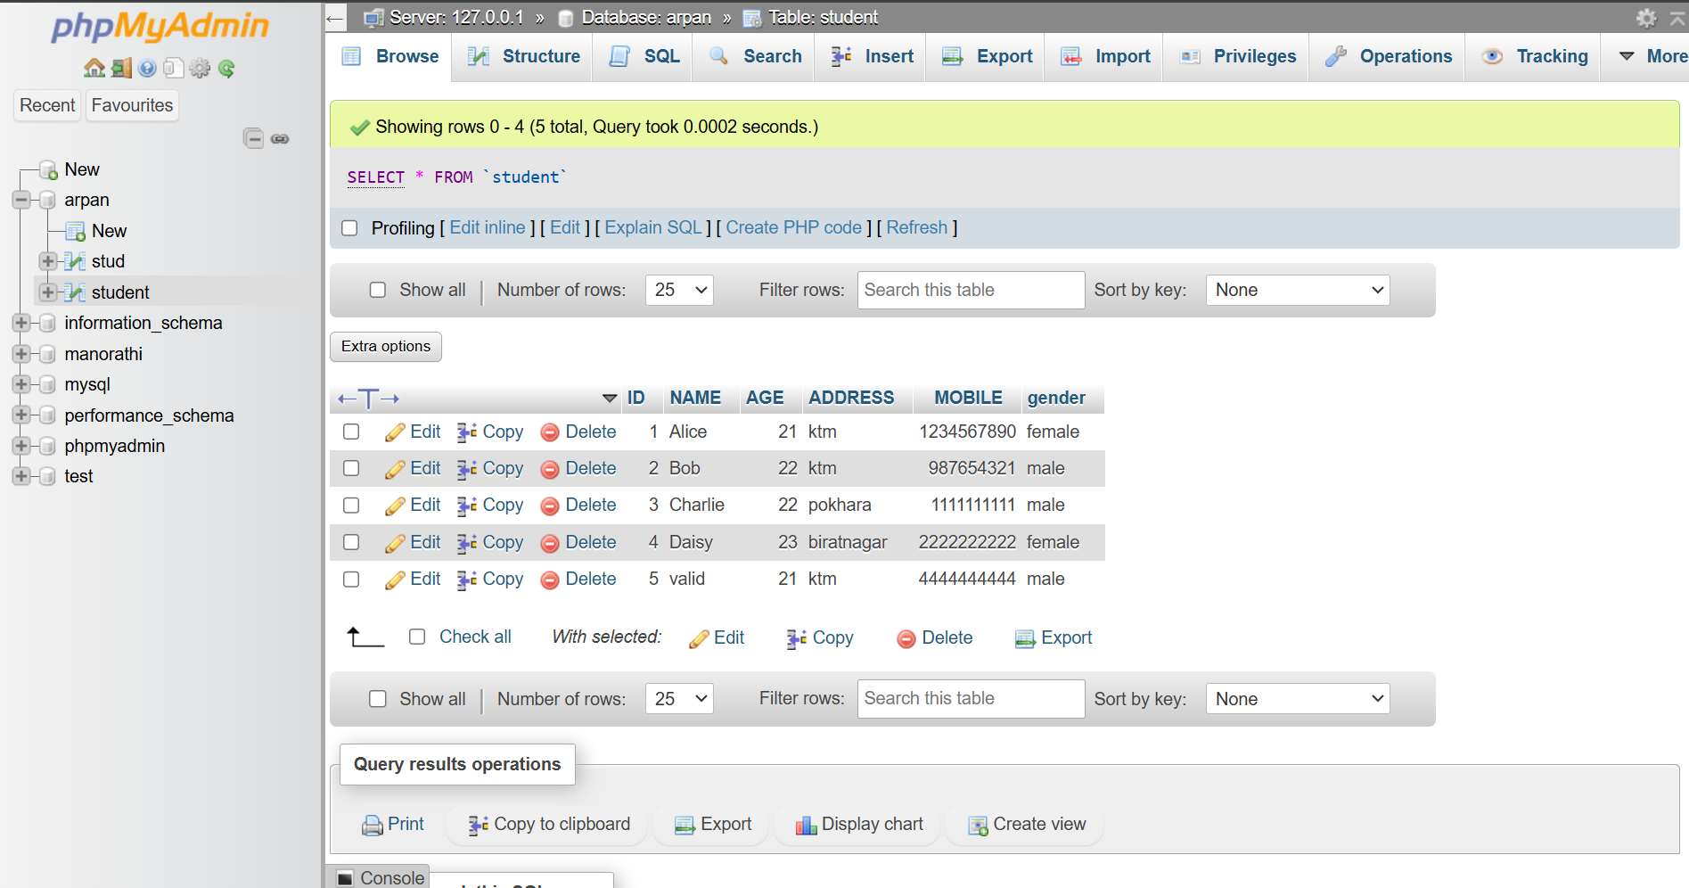

1. **Display all table info:**

SELECT * FROM student;

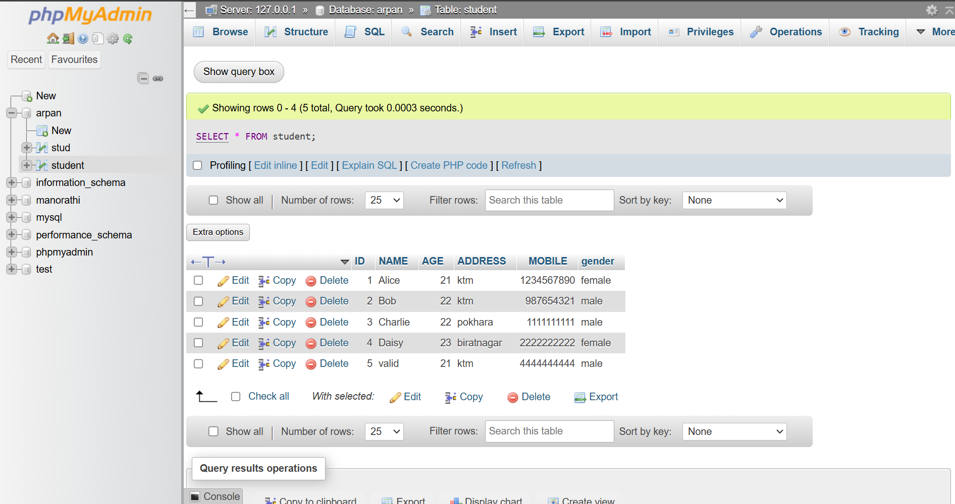

1. **Display distinct names:**

SELECT name FROM student;

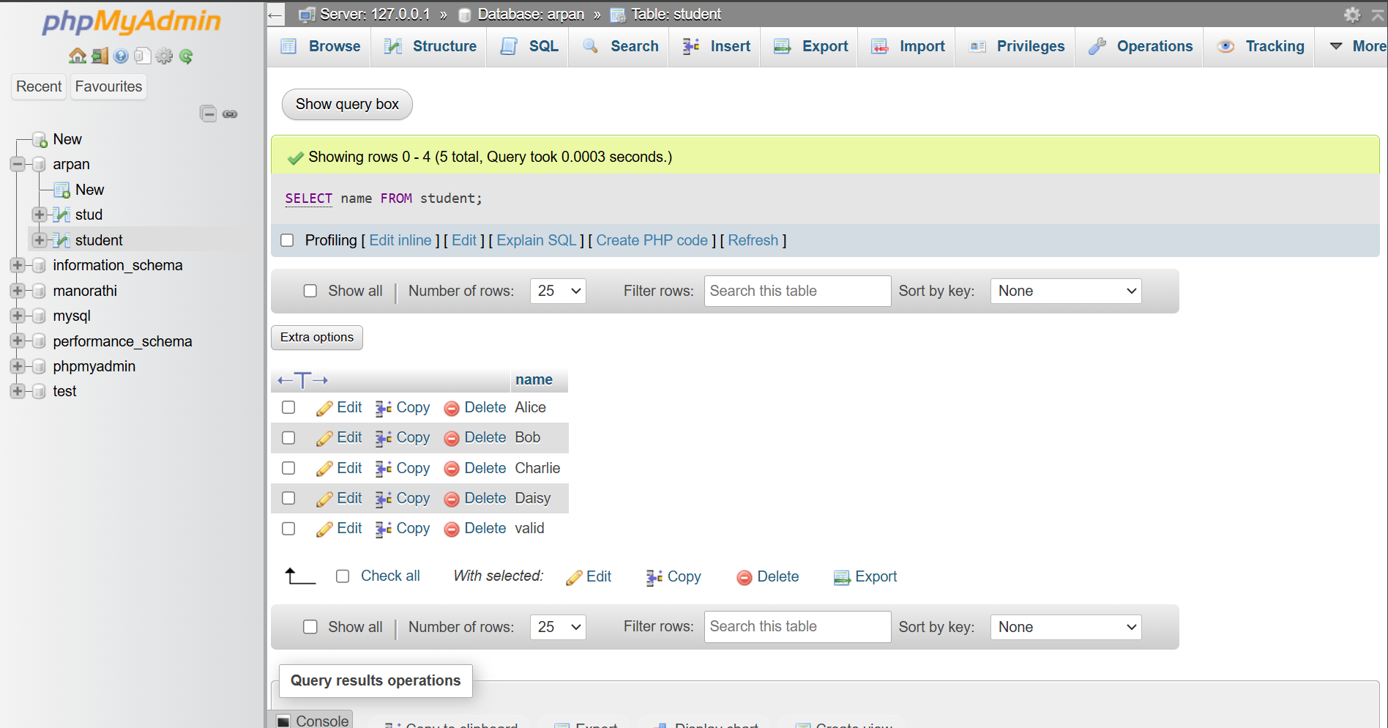

1. **Selecting name and id of Alice:**

SELECT name, id FROM student WHERE name = 'Alice';

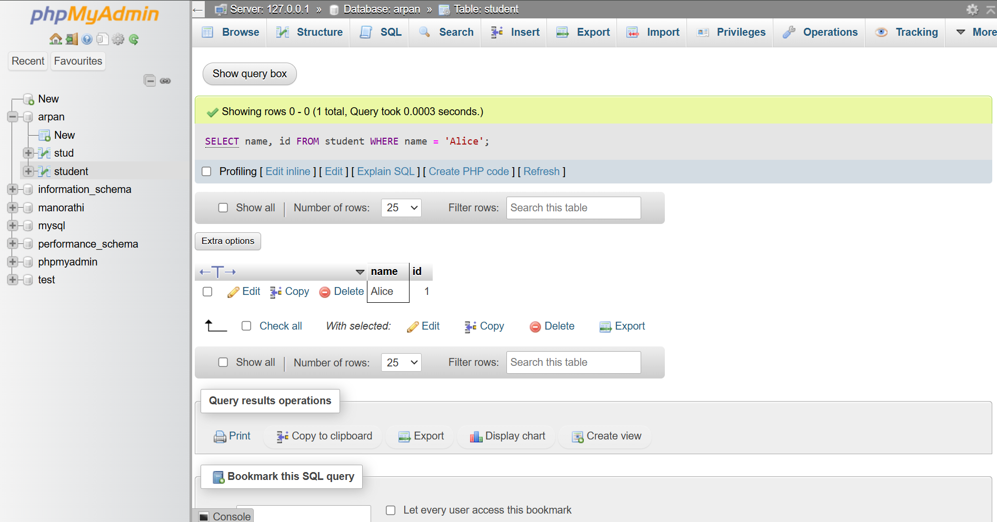

1. **Select info where id>5:**

SELECT * FROM student WHERE id > 5;

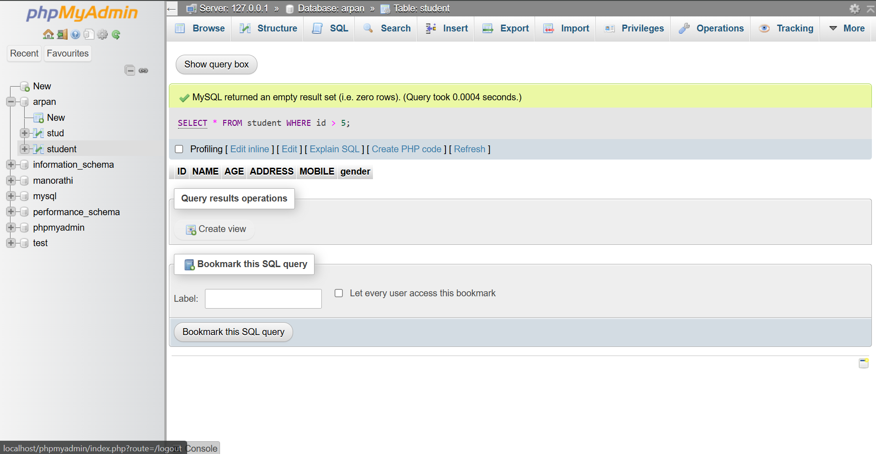

1. **Select info from table where name=alice and address=ktm**

SELECT * FROM student WHERE name = 'alice' AND address = 'ktm';

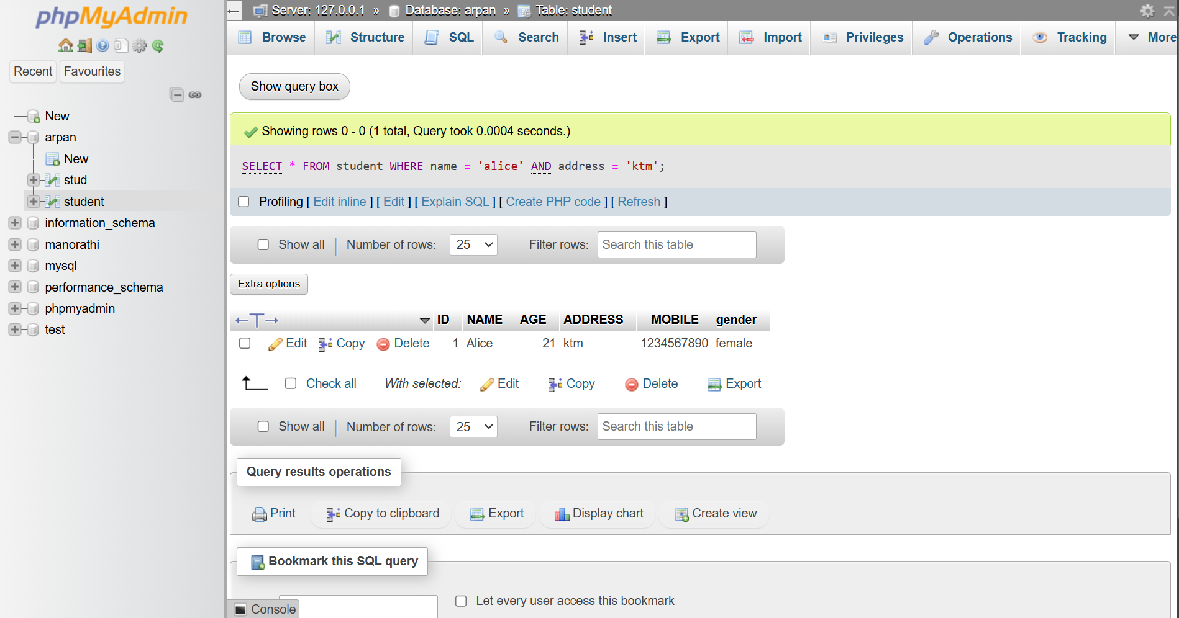

1. **Display Info of male:**

SELECT * FROM student WHERE gender = 'male';

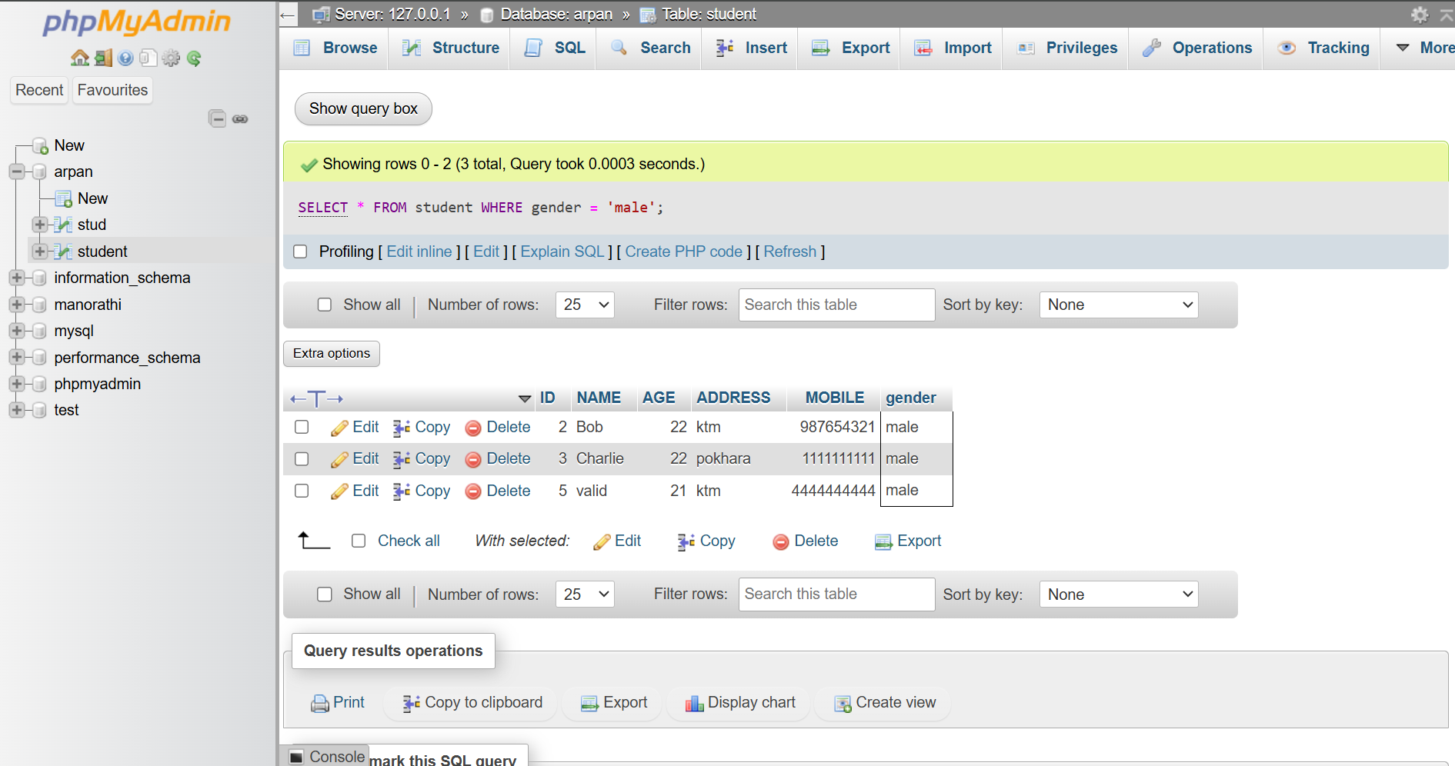

1. **Display name starting with A only:**

SELECT name FROM student WHERE name LIKE 'A%';

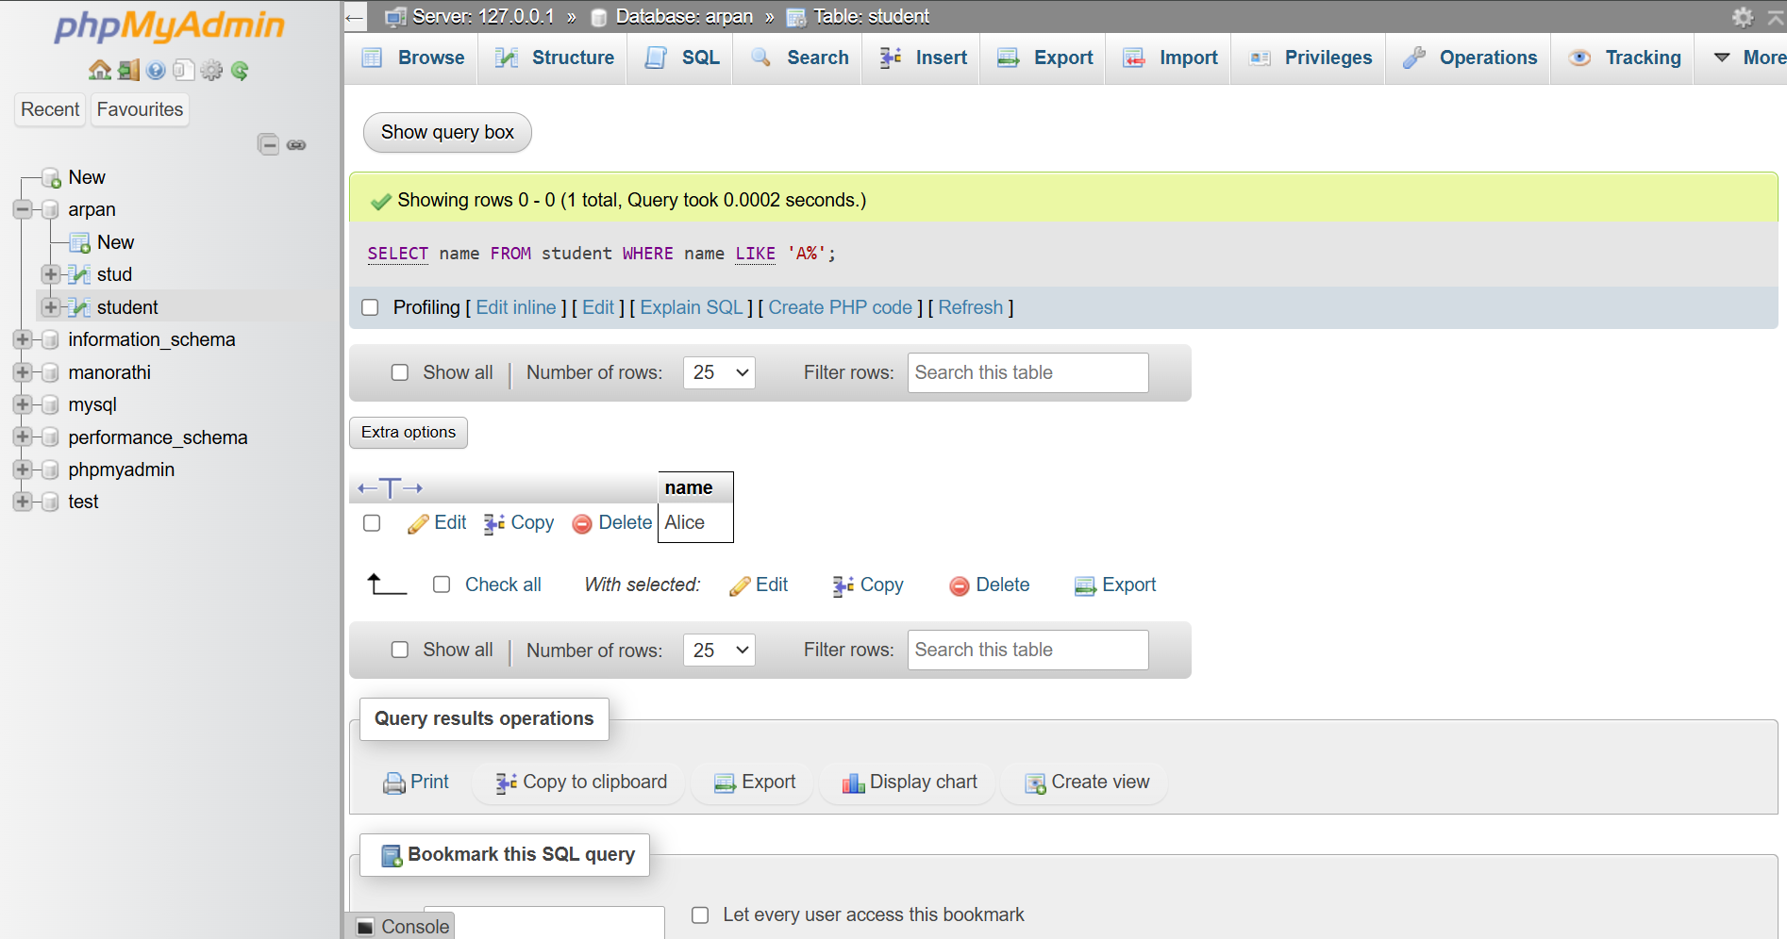

1. **Display Info of Female:**

SELECT * FROM student WHERE gender = 'female';

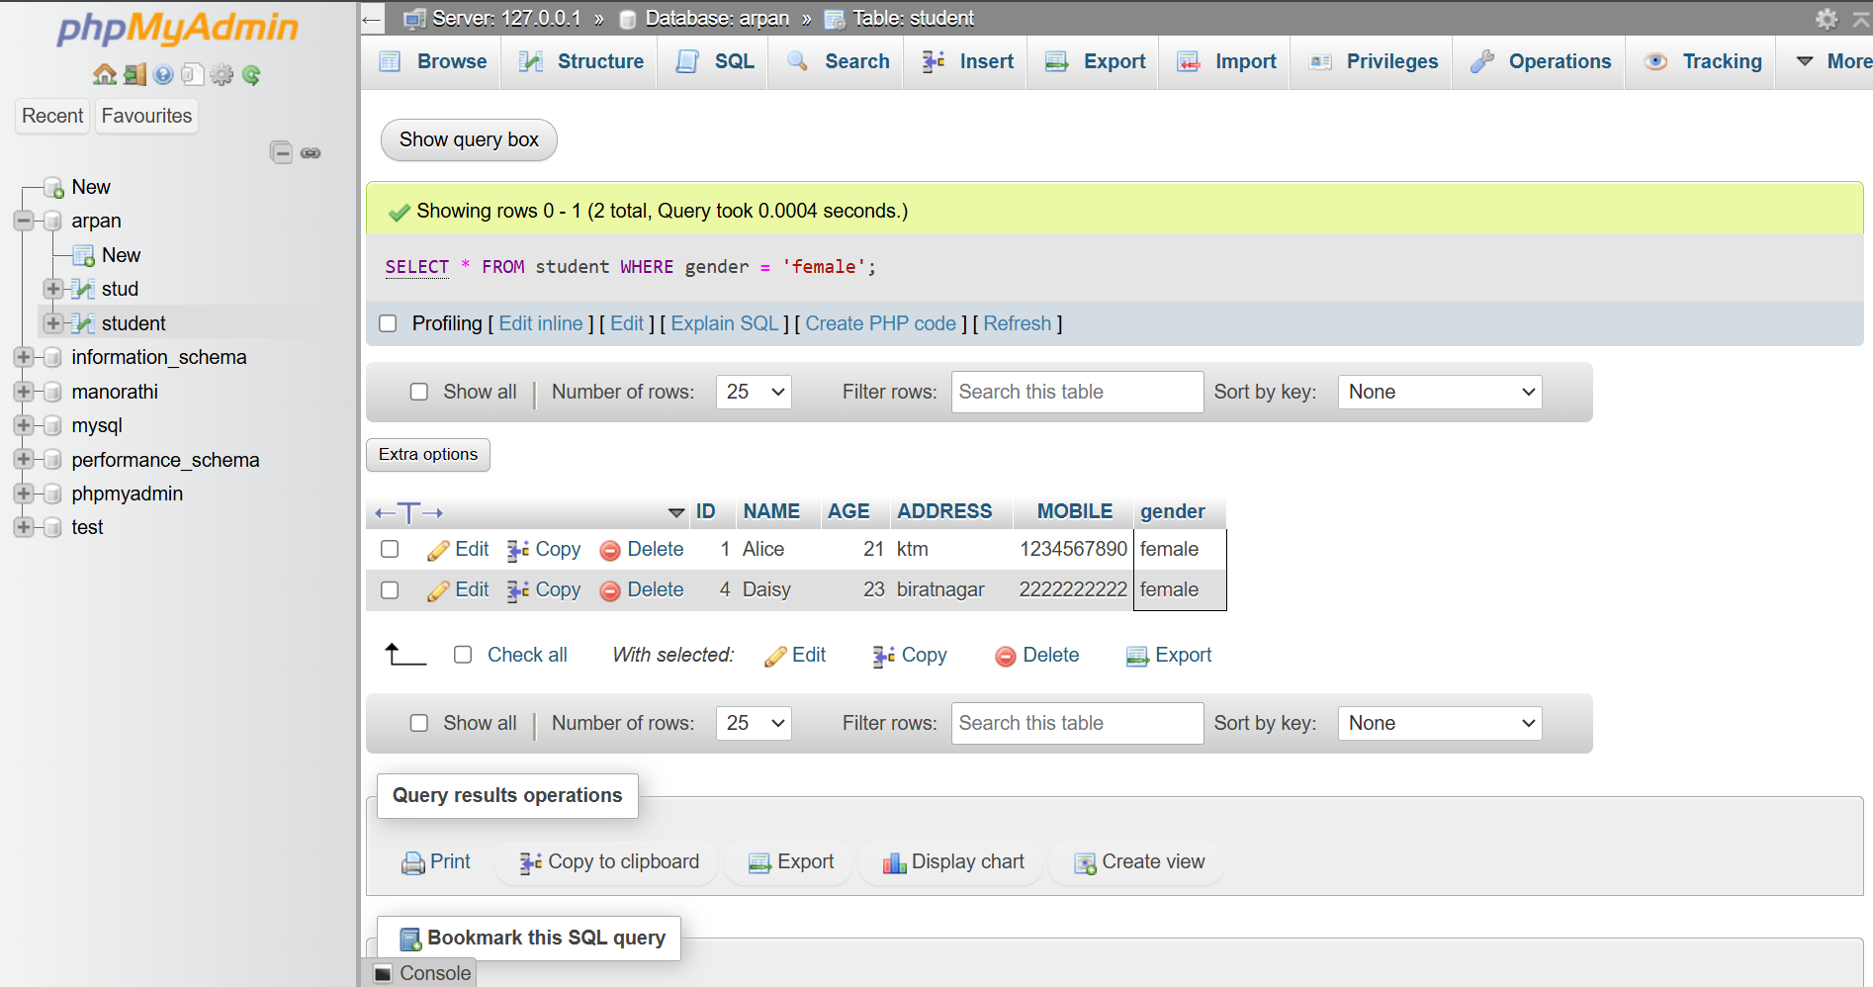

1. **Display name which last letter is e:**

SELECT name FROM student WHERE name LIKE '%e';

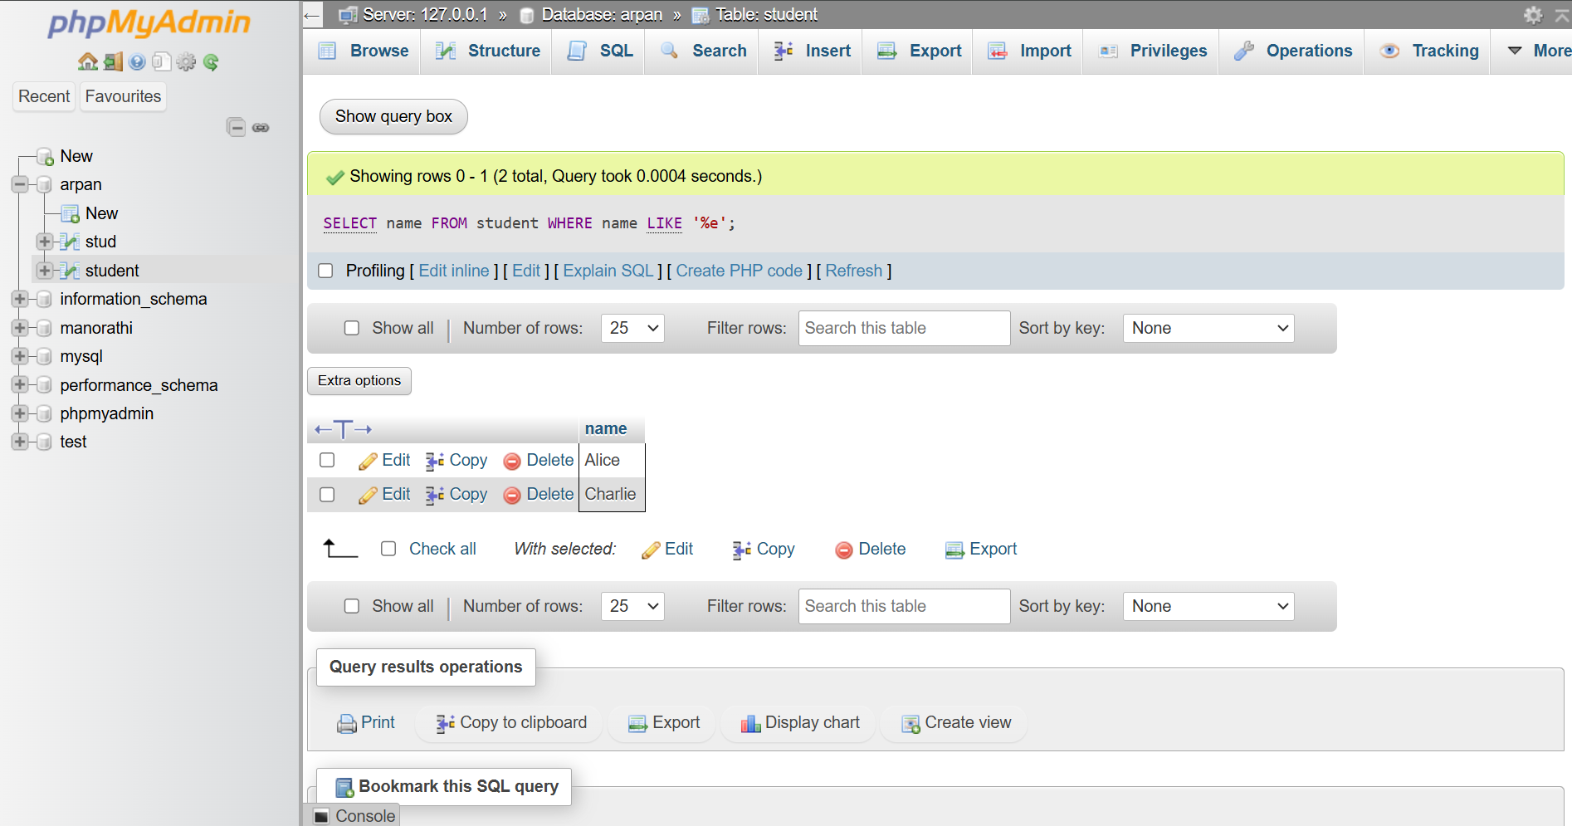

1. **Display name and age whose age is 19:**

SELECT name, age FROM student WHERE age = 19;

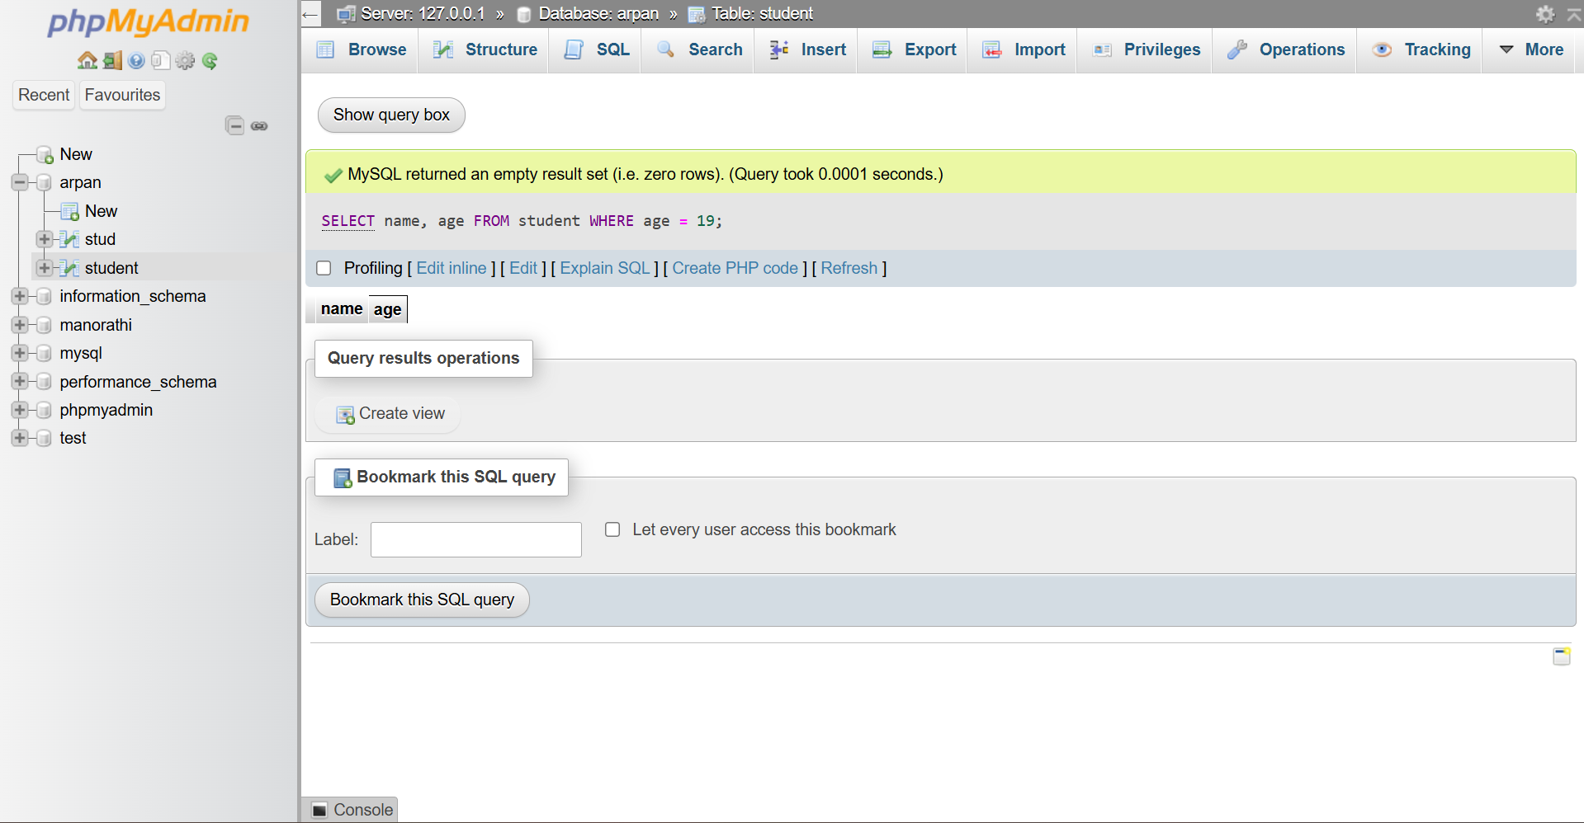

1. **Students with mobile number 0 at end:**

SELECT * FROM student WHERE mobile LIKE '%0';

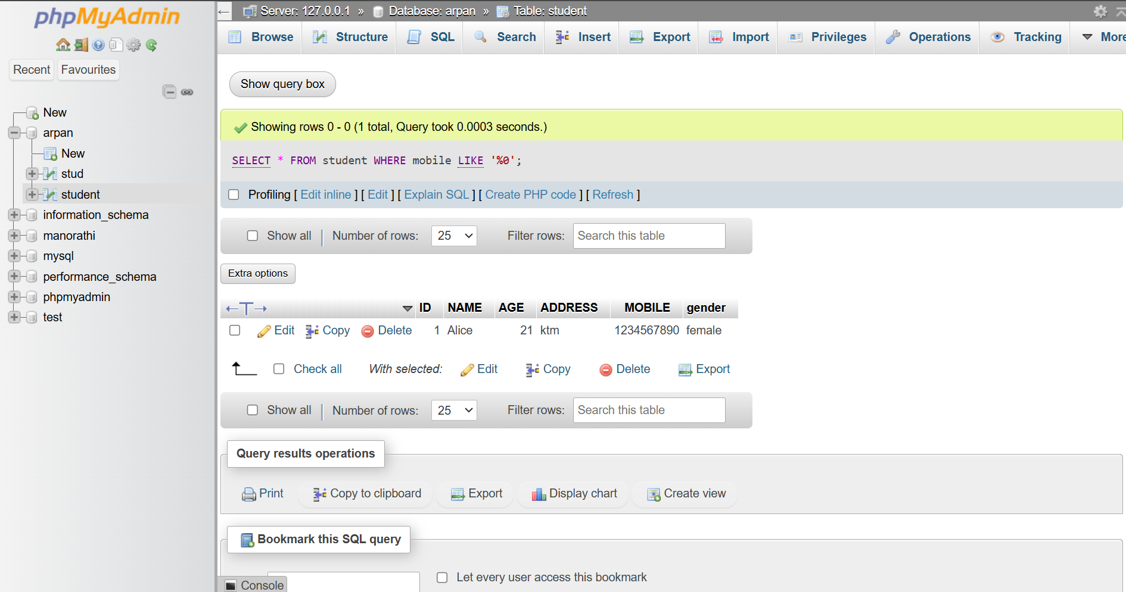

1. **Display distinct age:**

SELECT age FROM ‘student’;

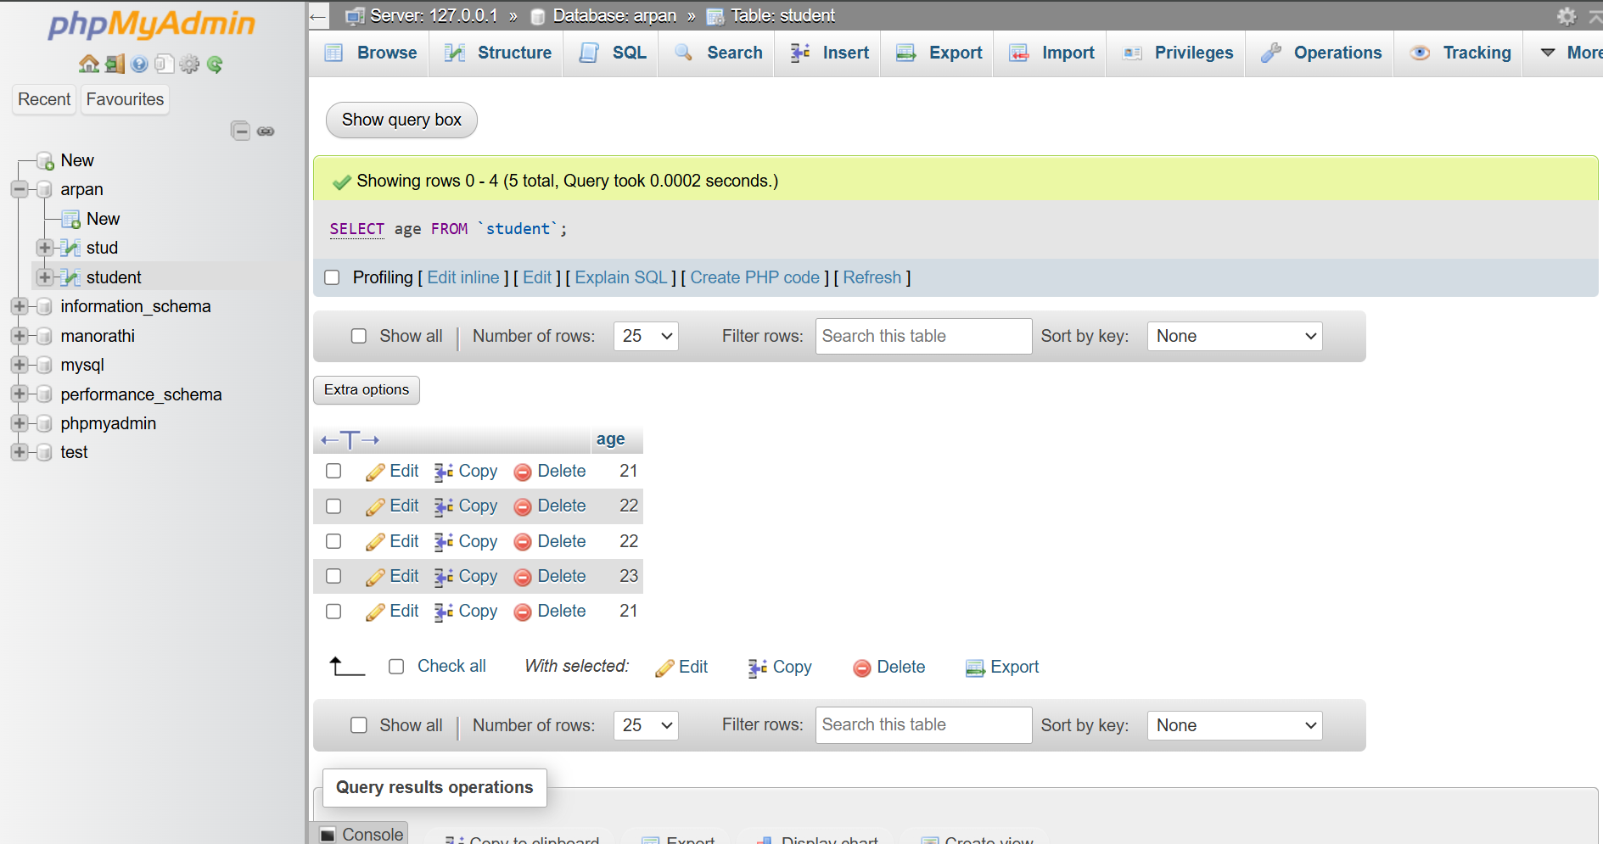

**18. Display student information which address is starting with k and ending with m.**

SELECT * FROM `student` WHERE address like 'k%m'

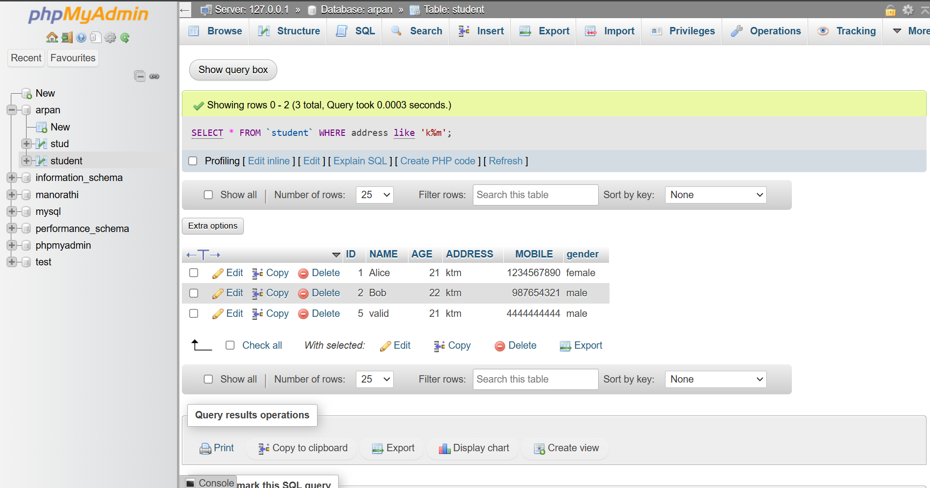

**19. Display student information which address is ending with u,n,a:**

SELECT * FROM student WHERE address LIKE '%m' OR address LIKE '%n' OR address LIKE '%a';

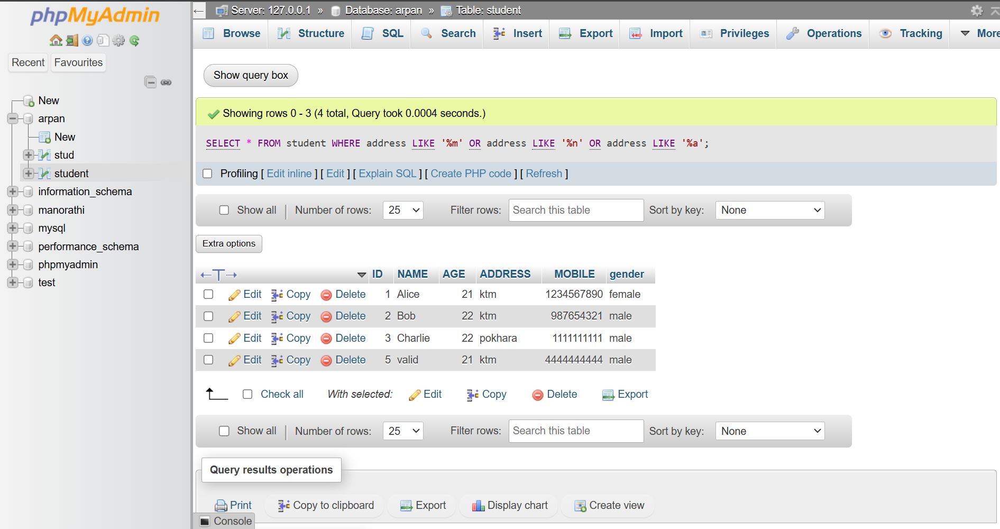

**20. Display student information which name is not starting with a,c,d.**

SELECT * FROM student WHERE name NOT LIKE 'a%' AND name NOT LIKE 'c%' AND

name NOT LIKE 'd%';

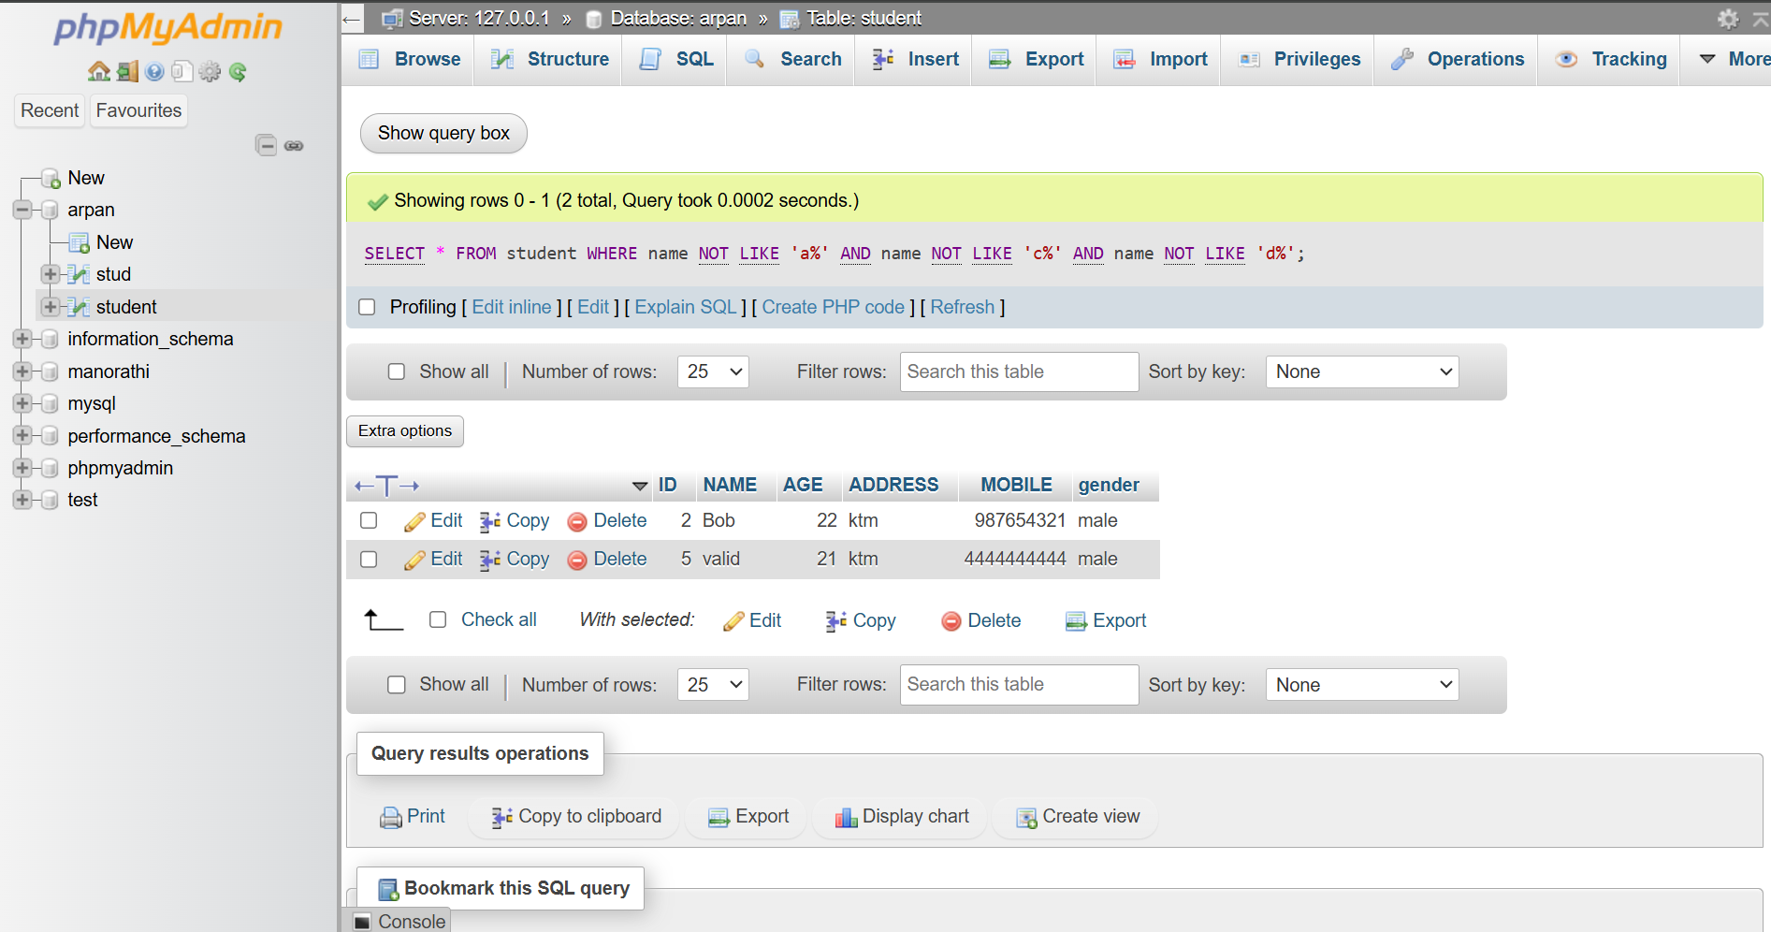

**21. Add new column marks and add check constraint marks>50:**

ALTER TABLE student

ADD marks INT CHECK (marks > 50);

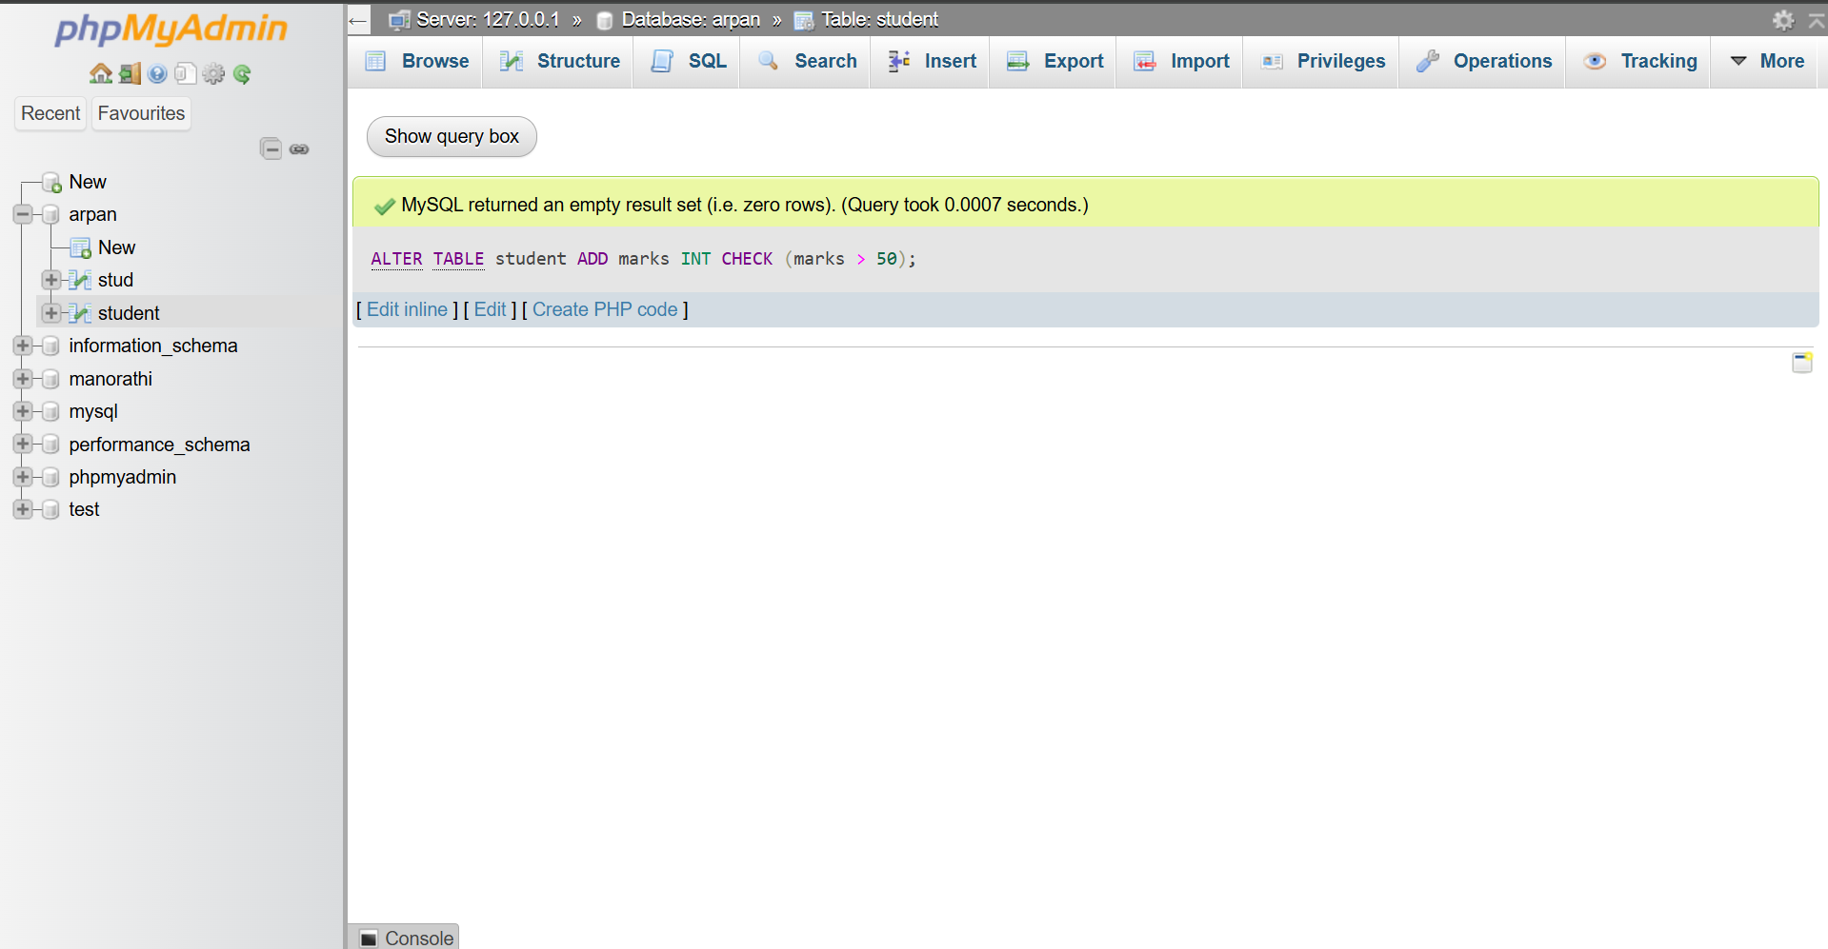

**22. Create new table teacher(tid,tname,taddress,tgender,tage)**

CREATE TABLE teacher (

tid INT ,

tname VARCHAR(100),

taddress VARCHAR(255),

tgender VARCHAR(100),

tage INT

);

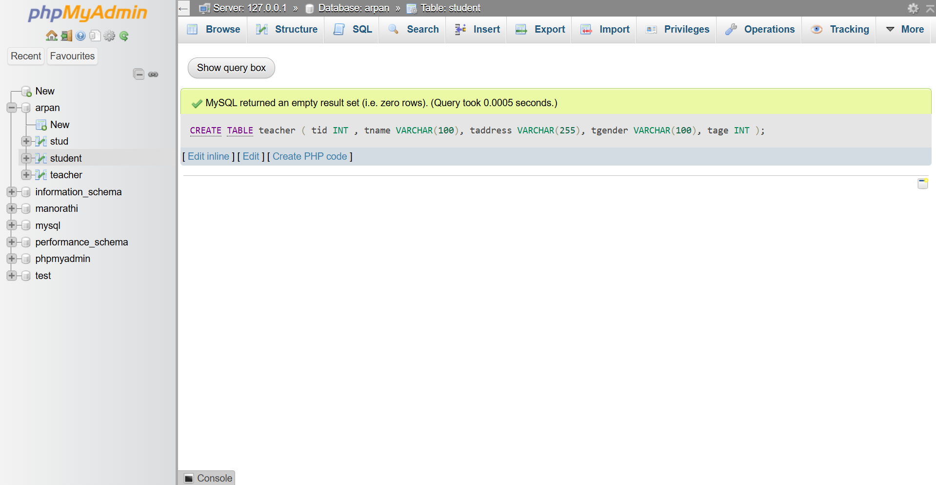

**23. Add constraint primary key to id,unique to name check to gender and default to address**

**as ktm:**

ALTER TABLE teacher

ADD CONSTRAINT pk_teacher_id PRIMARY KEY (tid),

ADD CONSTRAINT unique_name UNIQUE (tname),

ADD CONSTRAINT chk_gender CHECK (tgender IN ('Male', 'Female'));

ALTER TABLE teacher

ALTER COLUMN taddress SET DEFAULT 'ktm';

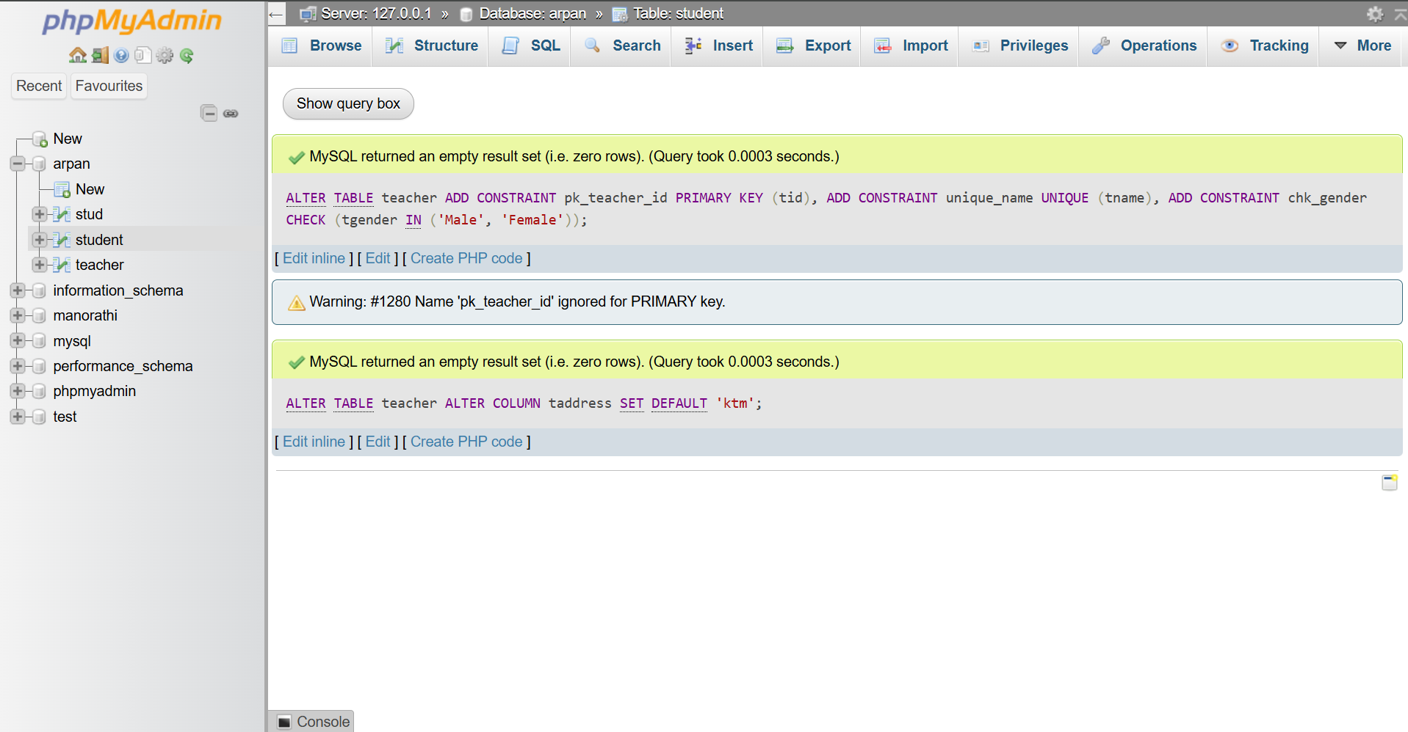

**24. Drop primary key:**

ALTER TABLE teacher

DROP primary key;

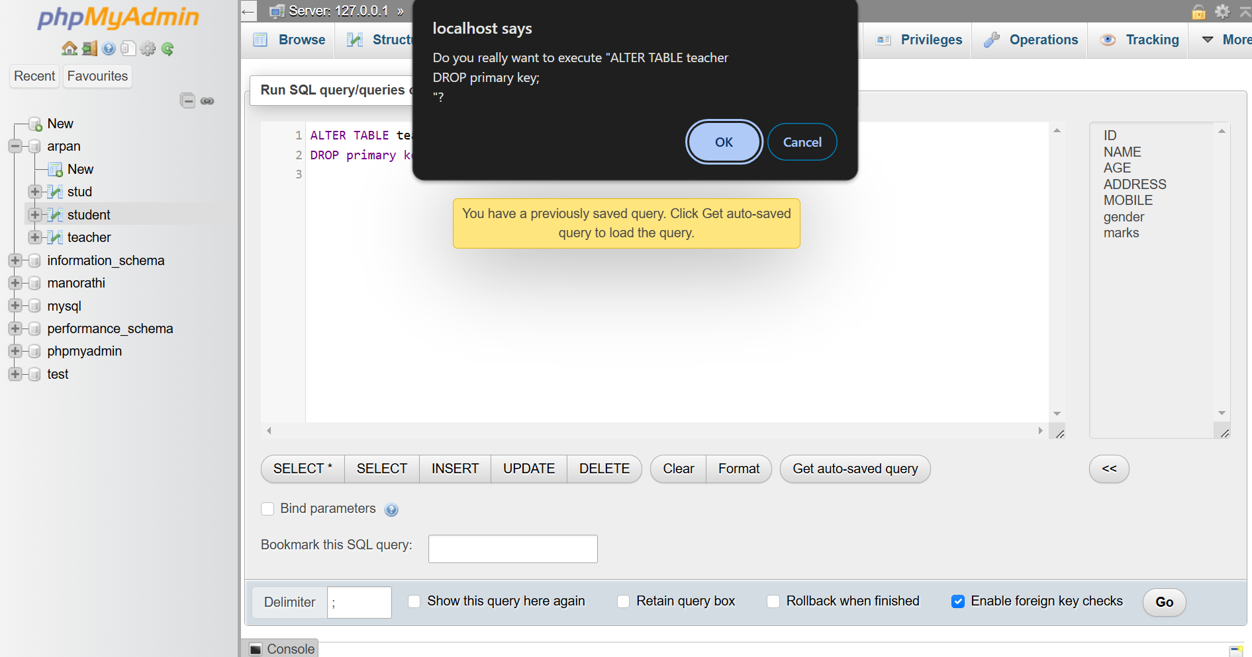

**25. Dropping foreign key:**

ALTER TABLE student

DROP CONSTRAINT mobile;

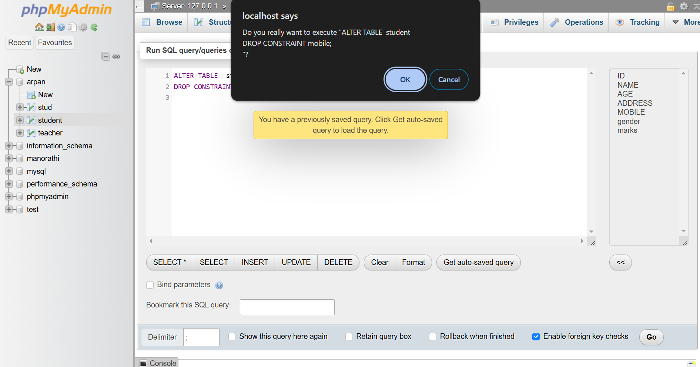

**26. Drop unique constraint**:

ALTER TABLE teacher

DROP CONSTRAINT tname;

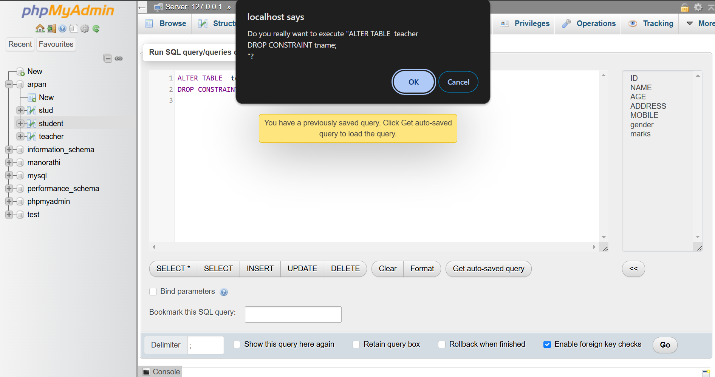

**27. Drop check constraint:**

ALTER TABLE student

DROP CONSTRAINT age;

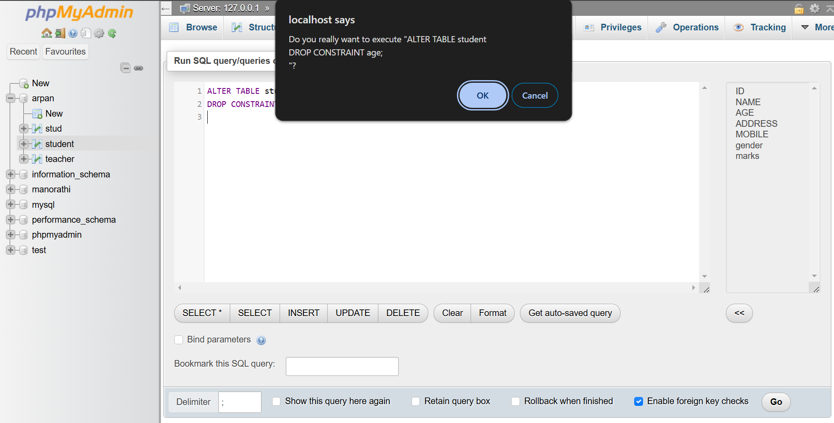

**CONCLUSION:**

In this practical, we learned how to apply various SQL constraints, such as PRIMARY KEY, UNIQUE, CHECK, and DEFAULT, to enforce data integrity and consistency in a database. We also explored the use of the ALTER TABLE statement to add, modify, and manage constraints effectively. By understanding and implementing these constraints, we can ensure that the database maintains accurate and reliable data while adhering to the required business rules and logic. This knowledge is crucial for creating robust and efficient database systems.